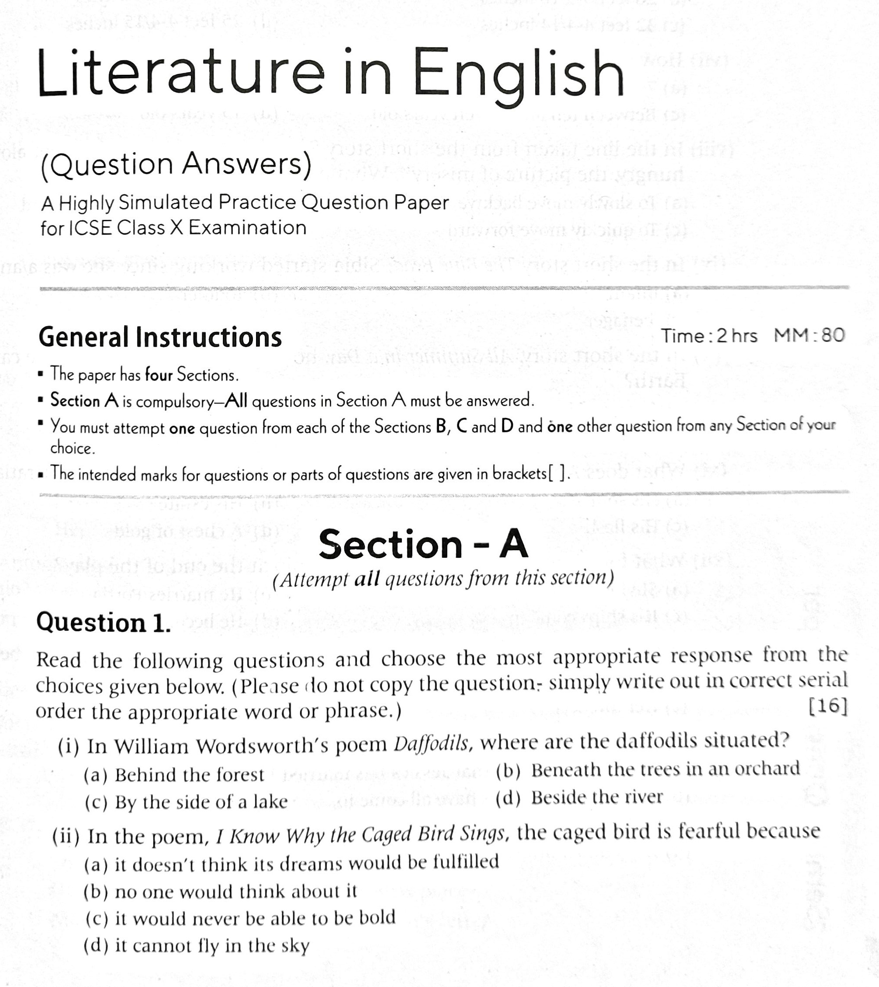

GUIDELINES

(By Subrata Sir & group of ICSE and CBSE school teachers)



Mock Test - 1

